**WEBSITE REFURBISHING PROJECT**

The goal of this project is to change the current face of the website [www.phosconsults.com](http://www.phosconsults.com) to a simple, very fast and beautiful website that represents a standard organization.

Below are websites that can be checked to emulate

<https://phillipsconsulting.net/>

<https://lydconsultingng.com/index.php>

<https://mentallyaware.org/>

<https://www.exness.com/>

<https://alderconsulting.com/>

Few Things to note in the previous website, that should be changed

1. The fonts
2. The contents spacing
3. The quality of pictures used
4. The slider quality and beauty (**Philips and LYD Sliders are very cool**)
5. Other changes are listed below

**BLOGS**

Change where we have Blog to Articles, I will also need one or two articles to display at the home page like a slider, or if you have a better way.

**PROJECTS**

Change where you have Gallery to Projects, Then We will have the following list under the projects. We will also have our gallery pictures under the listed projects

|  |  |  |
| --- | --- | --- |
| PROJECT TITLE | MONTH/YEAR | CLIENT |
| Baseline and Endline Survey for Livelihood Enhancement Training | August, 2022 | AFOS |
| 3000 clean data from teachers and lecturers (survey participants) Across The 6 – Geopolitical Zones of Nigeria | October 2021 | STEMRES |
| QUALITATIVE DATA COLLECTION AND TRANSCRIPTION OF THE “FUTURE OF WORK” PROJECT IN NIGERIA | May 2022 | STEMRES |
| Business Plan and Proposals Writings | November 2022 | Em-Creative Communications |
| Sales and Marketing Training | November 2022 | Business Growth Hub |
| **Raw materials quality, handling finished product packaging and storage material specification to meet quality and regulatory standards in Nigeria** | August 2022 | GAIN |
| Training Supervision For Agriculture Project II (AFOS AGRAR II) for Small Holder Farmer Training under the: livelihood enhancement training for 30,000 farmers in Lagos state, Oyo state, Ogun state, Osun state, Kwara state, Kogi state, Imo state, Enugu state and Edo state | April 2022 | MLDC |
| Business Plan | March 2022 | **STALITE MULTINATIONAL CONCEPT LTD** |

In addition to images already in the galley in the websites, add the images I will send to you.

**Welcome Note At The Home Page**

**Change it from:**

*Welcome to Phos Consults, we are a team of professionals focused on helping businesses enjoy growth. At Phos, we believe that "The problem is not lack of opportunity, but lack of preparation for opportunities"*

**Change it to:**

Welcome to Phos Consults, a team of professionals focused on helping businesses enjoy growth. At Phos Consults, we excel in both business strategy planning and implementation. We recognize the significance of corporate strategy to every company. From strategic planning to implementation, we'll assist you in transforming your business.

**SERVICES**

**Research and Data Collection**

We are dedicated to providing our clients with exceptional research and data collection services.

At our firm, we understand the importance of accurate and up-to-date information for making informed business decisions. That's why we offer a comprehensive research and data collection service to help our clients gather the information they need to make strategic decisions.

We specialize in providing comprehensive research and data collection services to help businesses and organizations make informed decisions. Our team of expert researchers is dedicated to providing our clients with the highest quality data and analysis.

We understand that collecting and analyzing data can be a daunting task, which is why we offer a range of research services to help our clients achieve their goals. Our services include:

1. Market Research: We conduct thorough market research to help businesses identify their target market and understand their customers' needs and preferences. Our market research services also help our clients to stay ahead of their competitors by keeping track of the latest industry trends and developments.
2. Customer Research: We provide our clients with insights into their customers' behavior, opinions, and preferences. This information is crucial for businesses looking to improve their products and services, tailor their marketing strategies, and build better customer relationships.
3. Data Collection and Analysis: We collect, clean, and analyze data from various sources, including surveys, interviews, and online databases. Our team uses the latest tools and techniques to ensure accurate and reliable data analysis, providing our clients with actionable insights.
4. Industry Research: We conduct comprehensive industry research to help businesses understand the competitive landscape, identify growth opportunities, and stay up-to-date with the latest industry trends and regulations.

At our consulting firm, we believe that data-driven decision-making is the key to success in today's competitive business environment. Our research and data collection services provide our clients with the insights they need to make informed decisions and achieve their business objectives.

Contact us today to learn more about how we can help your business succeed. (Make this last sentence a link that will lead to the page where our contact is)

**Business Development and Strategic Management**

We specialize in providing business development and strategic management services to help businesses grow and thrive in today's competitive market. Our team of experienced consultants is dedicated to providing customized solutions to help our clients achieve their goals.

We understand that every business is unique, which is why we take a tailored approach to our business development and strategic management services. Our services include:

1. Business Planning: We work with our clients to develop comprehensive business plans that outline their goals, objectives, and strategies for growth. Our business plans also include detailed financial projections and risk assessments to help our clients make informed decisions.
2. Market Analysis: We conduct thorough market analysis to help our clients understand their target market and identify growth opportunities. Our market analysis also includes competitor analysis to help our clients stay ahead of their competition.
3. Strategic Management: We help our clients develop and implement strategic plans that align with their business objectives. Our strategic management services also include performance measurement and monitoring to ensure our clients are on track to achieve their goals.
4. Organizational Development: We provide our clients with organizational development services to help them build high-performing teams and improve their overall organizational effectiveness. Our services include leadership development, team building, and change management.

At our consulting firm, we believe that strategic planning and effective management are essential to business success. Our business development and strategic management services provide our clients with the tools and resources they need to achieve their goals and drive growth.

Contact us today to learn more about how we can help your business succeed. (Make this last sentence a link that will lead to the page where our contact is)

**Learning, and Development Training:**

We run open courses, customized courses, and workshops in collaboration with both local and international subject-matter experts.

We understand that investing in employee learning and development is essential to business success. Our learning and development services are designed to improve employee performance, increase employee engagement and retention, and drive business growth. Our services include:

1. Training Needs Assessment: We work with our clients to conduct a comprehensive training needs assessment to identify areas where training and development is needed. Our needs assessment includes a review of existing training programs and a thorough analysis of job tasks, performance, and skill gaps.
2. Customized Training Programs: We design and deliver customized training programs that are tailored to our clients' unique needs. Our training programs include a range of delivery methods, including in-person training, e-learning, and virtual training.
3. Leadership Development: We provide our clients with leadership development training programs to help their leaders build the skills and knowledge they need to lead effectively. Our leadership development programs include coaching, mentoring, and training on leadership best practices.
4. Performance Improvement: We work with our clients to improve employee performance through targeted training programs and performance management strategies. Our performance improvement services help our clients to increase employee productivity and achieve their business objectives.
5. Coaching and Mentoring: We provide our clients with coaching and mentoring services to help individuals develop their skills and reach their full potential. Our coaching and mentoring services include one-on-one coaching, group coaching, and mentoring programs.
6. Learning Management Systems: We offer customized learning management systems to help our clients deliver and manage their training programs more efficiently. Our learning management systems include features such as online course delivery, progress tracking, and reporting.

**Below Is a List of Training Courses we have conducted:**

**Risk and Risk Management**

**Project and Change Management**

**Interpersonal and Cooperate Communications**

**Working with and in Teams**

**Value Oriented Management Corporate Culture**

**Emotional Intelligence**

**Convincing, Negotiating, Selling, and Business Etiquette**

**Self-Management and Delegation**

**Entrepreneurship and Leadership**

**Management by Objectives**

**Financial Analysis and Business Plan**

**Market and Consumer Insights  
  
(Please note that all these Listed trainings will have hyperlinks that will lead them to Articles we have written on them)**

Our learning and development services provide our clients with the tools and resources they need to enhance their employees' skills and knowledge, improve employee engagement and retention, and drive business growth.

Contact us today to learn more about how we can help your business succeed. (Make this last sentence a link that will lead to the page where our contact is)

**Human Resource Management**

Our human resource management services cover a wide range of areas, including:

Recruitment and Selection - We can help you identify the right candidates for your organization by developing job descriptions, conducting interviews, and assessing candidates' skills and experience.

Performance Management - Our team can help you design and implement performance management systems to ensure that your employees are meeting their goals and objectives.

Training and Development - We can help you create training programs that will enable your employees to acquire new skills and develop their existing ones.

Compensation and Benefits - Our team can help you design compensation and benefits packages that will attract and retain top talent.

Compliance - We can help you ensure that your organization is compliant with all relevant labor laws and regulations.

At our consulting company, we pride ourselves on providing customized solutions to meet the unique needs of each client. Whether you need help with recruitment and selection, performance management, training and development, compensation and benefits, or compliance, we have the expertise and experience to help you succeed.

Contact us today to learn more about our human resource management services and how we can help your organization achieve its goals. (Make this last sentence a link that will lead to the page where our contact is)

**Project Management**

Our team of experienced project managers has a proven track record of delivering successful projects across a variety of industries. We understand that every project is unique and requires a tailored approach to ensure success. That's why we work closely with our clients to develop customized project management solutions that meet their specific needs and objectives.

Our project management services cover a wide range of areas, including:

1. Project Planning - We can help you develop a comprehensive project plan that outlines the project scope, timeline, budget, and deliverables. Our team uses industry-leading project management software to ensure that your project plan is detailed, accurate, and up-to-date.
2. Risk Management - Our team can help you identify and mitigate potential risks that may impact the success of your project. We use a variety of tools and techniques to manage risks, including risk assessment, risk mitigation planning, and risk monitoring and control.
3. Stakeholder Management - We can help you identify and manage stakeholders, ensuring that their needs and expectations are met throughout the project. Our team will work closely with you to identify key stakeholders, develop a stakeholder management plan, and implement stakeholder engagement strategies.
4. Resource Management - We can help you allocate resources, including people, time, and budget, to ensure that your project is delivered on time and within budget. Our team will work closely with you to identify resource requirements, develop a resource management plan, and track resource usage throughout the project.
5. Communication Management - We can help you develop a communication plan that keeps all stakeholders informed and engaged throughout the project. Our team will work closely with you to develop a communication strategy, identify key messages, and implement communication channels and tools.

At our consulting company, we are committed to delivering successful projects that meet our clients' needs and exceed their expectations. We have the expertise and experience to help you achieve your project goals, whether you are launching a new product, implementing a new process, or expanding your business.

Contact us today to learn more about our project management services and how we can help you achieve your project goals. (Make this last sentence a link that will lead to the page where our contact is)

**Technology Services**

In today's business landscape, technology plays a critical role in the success of any organization. At our consulting company, we understand that businesses need reliable and efficient IT systems to operate at peak performance. That's why we offer a range of IT services designed to help businesses of all sizes and industries optimize their technology infrastructure.

Our IT services cover a wide range of areas, including:

1. Cybersecurity - We can help you identify and mitigate cybersecurity threats, ensuring that your sensitive data and systems are protected from unauthorized access.
2. Digital marketing services - We help businesses of all sizes reach and engage their target audience online. We offer a range of services, including search engine optimization (SEO), pay-per-click (PPC) advertising, social media marketing, email marketing, and content marketing.
3. IT Consulting - Our team can provide expert guidance on IT strategy, technology selection, and project management to help you make informed decisions about your technology investments.
4. Website Design – We have expertise in creating visually stunning, user-friendly websites that help businesses stand out from the competition. We take a collaborative approach to website design, working closely with our clients to understand their brand, target audience, and goals.
5. Technical Support - We offer comprehensive technical support services to ensure that your systems are running smoothly and that any issues are addressed promptly.

At our consulting company, we pride ourselves on providing customized IT solutions to meet the unique needs of each client. Whether you need help with network design and management, cybersecurity, cloud services, IT consulting, or technical support, we have the expertise and experience to help you succeed.

Contact us today to learn more about our IT services. (Make this last sentence a link that will lead to the page where our contact is)

PLEASE CHANGE THE NUMBER ON THE WEBSITE FROM 08130232512 TO 07051381049

Update the Gallery pictures, find the link to more pictures

<https://drive.google.com/drive/folders/1f3E09ffpHbo5QA4pTar1uuZYlE73XyVV?usp=share_link>

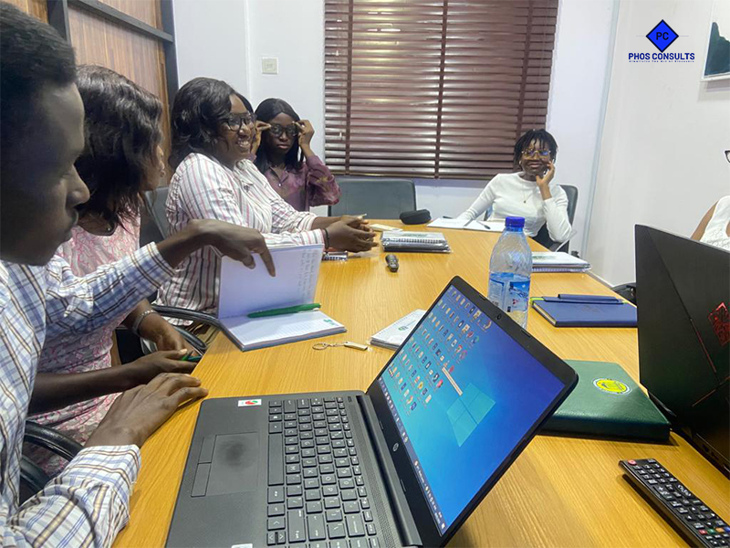A strategy session with Gamble Alert

**Clients**

**Stalite Multinational Concept Limited**



**Gamble Alert**



**Microfinance Learning and Development Centre**

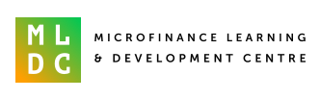

**STEMRES**



**PFARMS LIMITED**

